May 2011
Vol. VIII, Issue #83
 Bergen ME/ CFS-FM Support Group Newsletter
Meeting

NOTE: THE JUNE MEETING IS ON JUNE 12TH – THE SECOND SUNDAY – SINCE THE THIRD SUNDAY IS FATHER’S DAY!

May 15th may have been a dreary day, but those who attended the meeting shared a few laughs and poignant moments. The agenda featured the showing of the 1985 Golden Girls 2-part season opener, “Sick and Tired.” It was written by writer/creator Susan Harris before she left the show because of her own CFS. “Sick and Tired” was based on her personal experiences. In the story, Dorothy became ill with CFS, and her experiences were familiar to many in the room.

CFSAC (Chronic Fatigue Syndrome Association [Federal] Advisory Committee)
The latest meeting was held in May. A Videocast of the proceedings is available at http://www.hhs.gov/advcomcfs/. The link can be found in the right column under “Spotlight.”

Chase Community Giving

This support group and the NJCFSA congratulate the Whittemore Peterson Institute (WPI) and CFIDS Association of America for winning $25,000 each in Round 1 of the Chase Community Giving campaign. Your votes made that possible. In Round 2, WPI won an additional $40,000.

SoK Meeting
In an earlier newsletter, we told you about The State of the Knowledge Workshop on ME/CFS Workshop that was held in April. It brought together researchers, advocates and patients to discuss CFS.

The video of both days of the State of the Knowledge Workshop on ME/CFS Research (April 7-8, 2011) has been uploaded to the NIH VideoCast Past Events page: http://videocast.nih.gov/PastEvents.asp.

SoK Meeting Report
Summary Session: Pat Fero Executive Director, Wisconsin ME/ CFS Association

Session chairs and co-chairs had the opportunity to do short summaries of each session for the two days. There was an attempt to have some discussion, but our time was short. We had far less than the 2.5 hours and in my opinion it did not go well. We did not establish gaps in knowledge. This missed the opportunity to discuss case definitions as a basis for contradictions in research findings. Further discussion on all topics was limited leaving no time to talk about strategies to begin to sort out the mess. In her closing remarks, Vivian Pinn, MD, head of the Office of Research and Women's Health, commented on this shortcoming. She wanted more discussion, more exchange among scientists and some closure.

Conclusions:
I watch people. I saw more sitting forward than leaning slouched into a chair. It is easy to note intensity as compared to boredom. The room was filled with NIH scientists most of whom were learning about CFS for the first time.

The agenda was as sparse as the Committee could make it, and yet each session ran into the next. I know this is common at conferences. Scientists wanted to keep talking, to interact, to strategize and to ask questions…all good. The meeting was not finished because we did not accomplish goal 2 and 3, to look for gaps in our knowledge needing more research, and to identify outstanding opportunities. I wrote a letter to Dr. Pinn about bringing the scientists together to hash it through. We need strategies.

I was thinking about newly established Centers, so popular, and so well funded at the NIH. We want Neuroimmune and or Neuroendocrine immune centers, but I think there is a long process among collaborating scientists to accomplish this. We have researchers and doctors in clumps like Miami and Salt Lake City. We even have a Neuroimmune Institute in Reno. What we don't have is a platform where dedicated well-known researchers haul in others to form a community where ideas are stashed and slashed and made into something new. I think this is how other centers have formed…. not just as patient efforts, but also as researcher think tanks. The end result of creating a platform, is asking for a train.

To the best of my abilities, I tried to represent patient interests.
Thank you for the trust that I could help us in some way. As you know, many other patients have written NIH SOK conference summaries highlighting sessions in some detail. Others I met at the meeting were terribly disappointed in the proceedings. I understand this. How many times have we run this maze to be angry at the outcome? I will be disappointed and angry if a subsequent meeting is not held to finish this one.

My thanks to Dr. Dennis Mangan who came into this full speed ahead and did a very good job at herding cats.

PAT FERO, MEPD
Executive Director,
WI ME/ CFS Association, Inc

NJCFSA Fall Conference – SAVE the DATE

The flyer on the following page announces the speakers for the conference. The topics include diagnosis and clinical management of CFS - topics that doctors have requested. You can print the page and share it with as many doctors as possible.

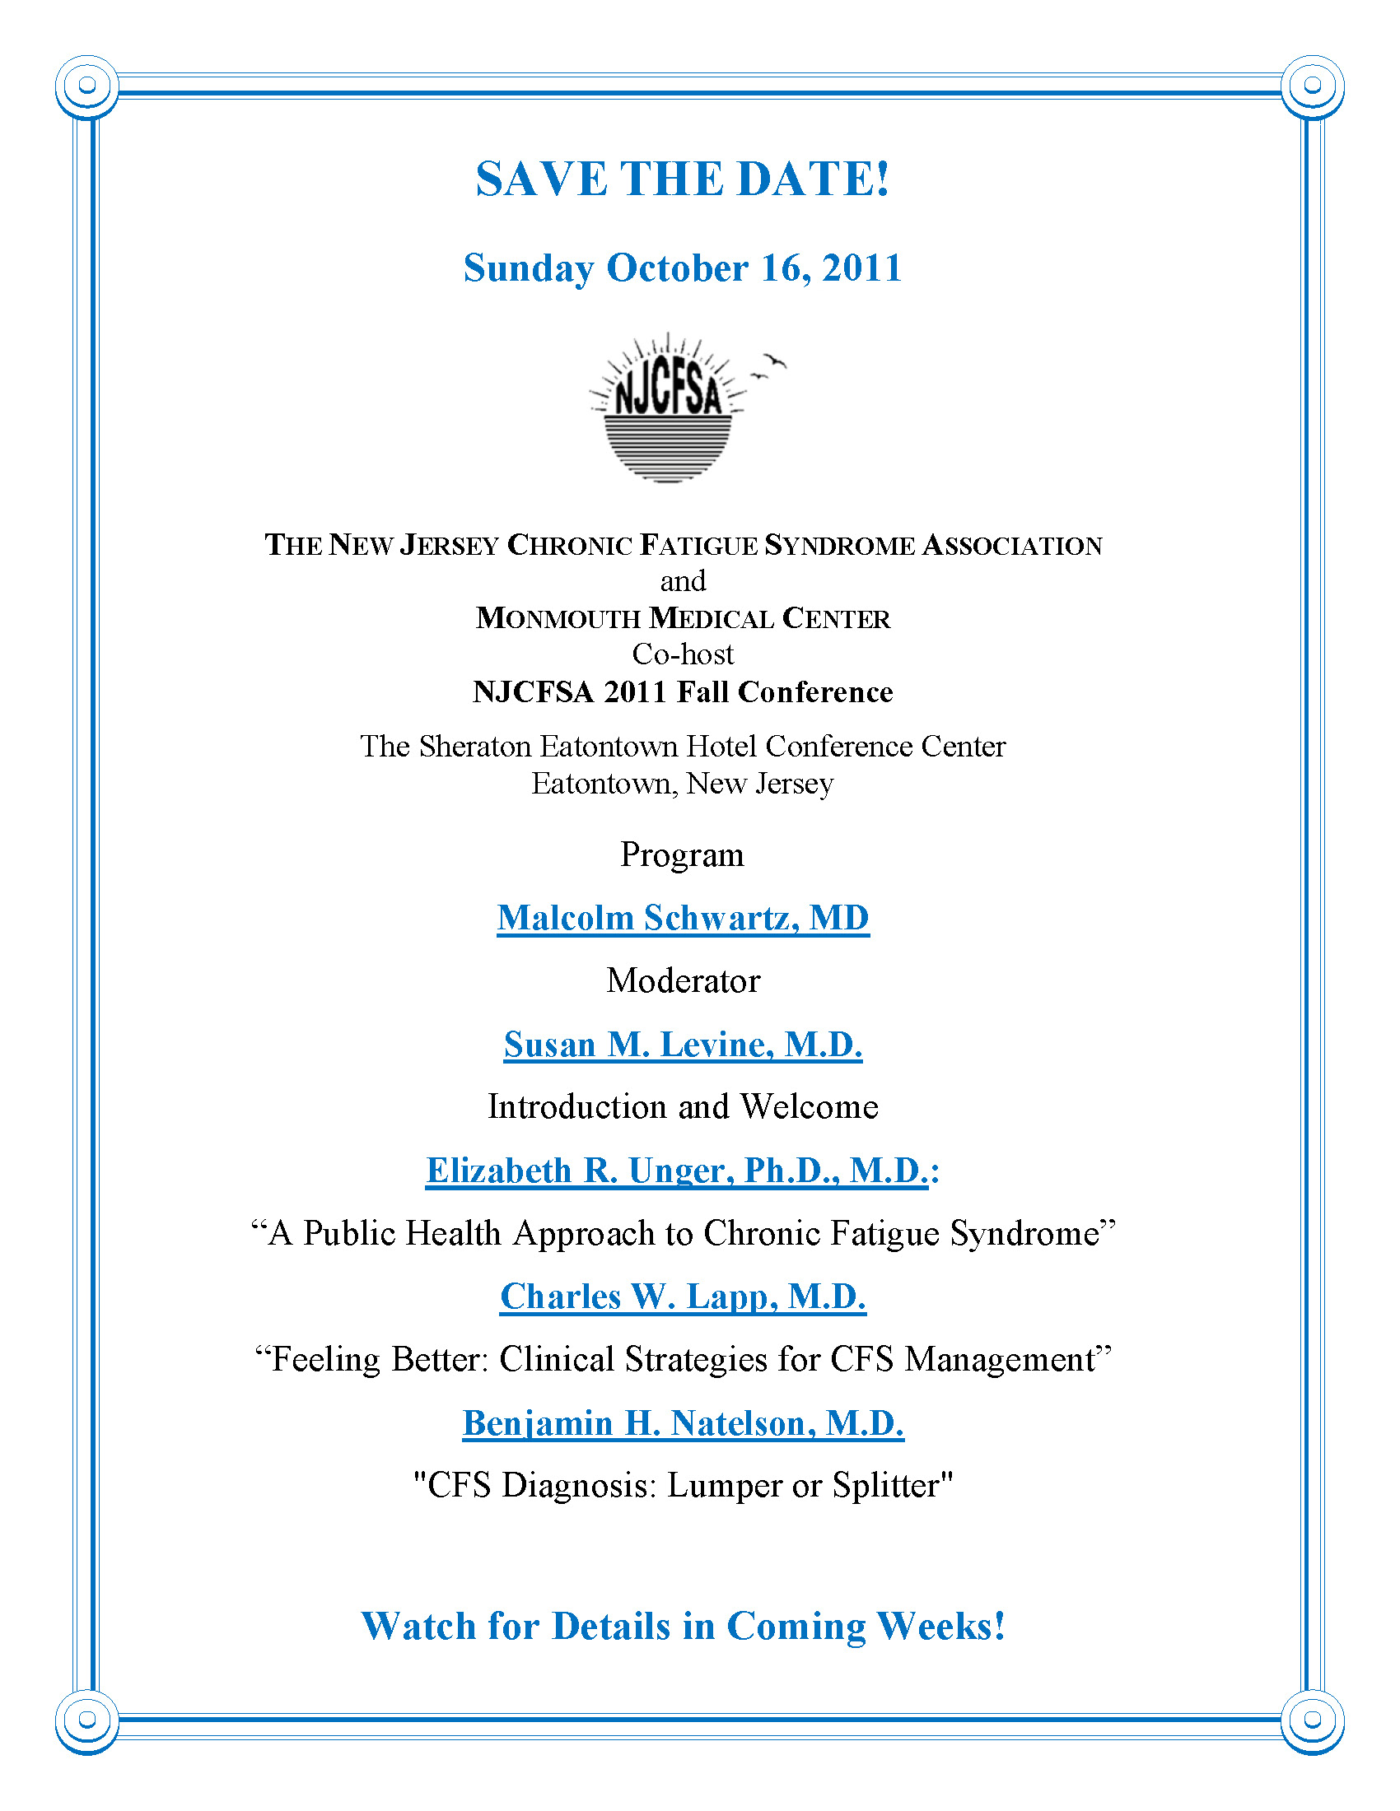
Next Meeting
The next meeting will be held on June 9th. THIS IS THE 2ND SUNDAY SINCE THE THIRD SUNDAY IS FATHER’S DAY.

This newsletter is intended for ME/CFS & FM patients in the area of this support group. The purpose is to share information and support. If you have questions about meetings please contact: Nancy Visocki at ngv.njcfsa@verizon.net, Judy Machacek at judymachacek@msn.com, Pat LaRosa at pcl.njcfsa@gmail.net or leave a voice message at the JCFSA HelpLine 888-835-3677 during business hours. Please note: The HelpLine is not in a staffed office. It is voice mail that is answered by NJCFSA volunteers – within 48 hours (sometimes sooner.) If you are in crisis, seek emergency assistance (such as 911.)

WEATHER or EMERGENCY – In the event of bad weather, or other emergency, we encourage you to check your email before leaving for Englewood. If it has been decide that a meeting will be canceled, an email will be sent via the yahoogroups list. The Hospital will also be notified of the cancellation. The email posting also applies to a cancellation of the First Wednesday of the Month luncheon which is an informal gathering, an opportunity for people to meet and chat with other members.

