April 2011
Vol. VIII, Issue #82
 Bergen ME/ CFS-FM Support Group Newsletter
Meeting
The April meeting featured speakers and information related to sleep disorders. Unfortunately, I was unable to attend. I understand from the other leaders that it was n informative presentation. When information becomes available I will include it in a future newsletter.

ME/CFS Month
May is ME/CFS month. More specifically, May 12th is International ME/CFS Day. It is a a time to share awareness of this illness with doctors, nurses, family, friends, teachers – anyone you can. Join the NJCFSA and this support group by helping to spread the word.

For their 2011 ME/CFS Awareness project, the NJCFSA will be sending the anesthesia information (available at www.njcfsa.org) to the anesthesia department of every hospital in the state of NJ. Hopefully, it will increase awareness among the anesthesiologists and anesthetists in New Jersey. (By the way, the initial feedback from patients who have brought these documents to their dentists and physicians has been very positive.)

If you need an idea for May 12th Awareness Day, one option you might want to consider could be The NJCFSA Awareness Poster can be found is available on the NJCFSA website http://www.njcfsa.org/poster-project. It can be emailed or printed. While I wanted to include the poster directly in this email, it did not work well and I did not want the mailing to be slow to open for you.

About the Lynn Bousquet, the designer of the 2010 NJCFSA Poster - After retiring from 20 years in the advertising field due to ME/CFS, Lynn has sought to make a difference in the community by using her graphic artist skills to help many ME/CFS organizations get their message out. Her newest passion is making videos. She is happily married and is lucky to have six grandchildren. Lynn, also an artist, loves to paint in watercolor and acrylic when she can find the energy.

FM in the News
National Fibromyalgia Awareness Day
A look back with the NFA
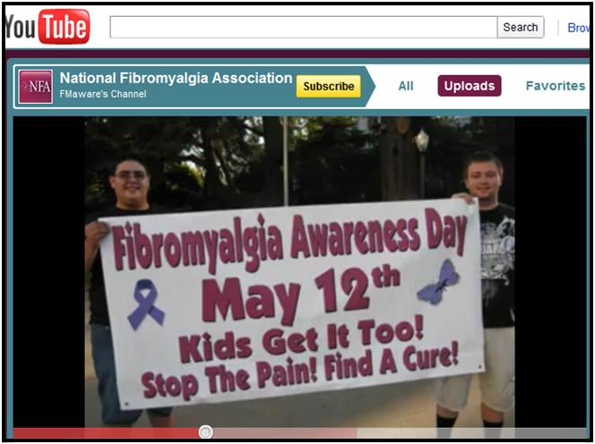
With the ongoing support and cooperation of the NFA's corporate sponsors and nationwide network of Support Groups, National Fibromyalgia Awareness Day has become one of the most successful outreach campaigns in terms of media exposure and raising general awareness. Read more at http://fibroblog.org/2011/04/25/through-the-years-the-nfa-and-national-fibromyalgia-awareness-day

ME/CFS in the Local News
This info is from Linda Cross of the Bergen. County Dept. of Human Services, Division of Senior Services.
Do you know that a wheelchair rider being transported in a van is not required to be secured with a seat belt? Imagine, just one quick stop, an accident in the blink of an eye--could throw that rider out of the wheelchair with the force of a bullet.
For details on wheelchair securement visit: http://www.youtube.com/watch?v=EZJVUpxk0kA
Promote awareness and support the passage of Bill A3867
Amy Chan and Rene Cantwell were in Trenton [on 05/05/11] to testify to the Transportation Committee on the details that lead to us pursuing passage of the Wheelchair Securement Act. The testimony was received very well and when finished they were advised by the Chairman of the committee Assemblyman John S. Wisniewski, that he would be signing on as co-sponsor with Assemblyman David Russo. This gives the bill bi-partisan support. They were also given assurances that there was widespread support for the bill and that action would take place quickly. Furthermore, Senator O'Toole will be introducing a Senate version of the bill at the next meeting on May 12.
05/09/11 update:
The following bill(s) have been scheduled for a committee or a legislative session.
A3867:
5/5/2011 10:00:00 AM Transportation, Public Works and Independent Authorities
The committee shall discuss and take testimony on the Administration's proposed Statewide transportation capital plan and funding of the Transportation Trust Fund for Fiscal Year 2012 and thereafter. The committee has invited experts and the public to testify on these issues.
Committee Room 4, 1st Floor, State House Annex, Trenton, NJ
http://www.njleg.state.nj.us/bills/BillView.asp?BillNumber=A3867.
Department of Human Services
http://www.state.nj.us/humanservices/dmahs/home/index.html
Division of Medical Assistance and Health Services
This site has a lot of information including:
Medical Assistance Customer Centers * NJ Prescription Drug Price Registry
New Jersey County Welfare Agencies (and Boards of Social Services)

CFSAC (Chronic Fatigue Syndrome Association [Federal] Advisory Committee)
Bottom of Form

Posted by The CFIDS Association of America

The DHHS CFS Advisory Committee meeting begins Tuesday morning at 9 a.m. (Eastern). The two-day meeting will be webcast. Here's the link to watch online: http://tiny.cc/uxm1b

Chronic Fatigue Syndrome Advisory Committee
nih.granicus.com
The Chronic Fatigue Syndrome Advisory Committee (CFSAC) provides advice and recommendations to the Secretary of Health and Human Services via the Assistant Secretary for Health of the U.S. Department of Health and Human Services on issues related to chronic fatigue syndrome (CFS).

Chase Community Giving

This support group and The New Jersey Chronic Fatigue Syndrome Association, Inc. (NJCFSA) sent congratulations to the Whittemore Peterson Institute (WPI) and CFIDS Association of America for winning $25,000 each in Round 1 of the Chase Community Giving campaign. Your votes made that possible. Round 2 begins on May 19th. You can help decide which of the winning charities share the remaining $2.5 million. All who Facebook accounts are encouraged to vote for these organization during round 2. These two organizations are involved in research that may help each of us.
http://www.facebook.com/ChaseCommunityGiving#!/ChaseCommunityGiving?sk=app_162065369655 or http://www.facebook.com/ChaseCommunityGiving and look for the voting link.

Next Meeting
The next meeting will be held on May 15th.

This newsletter is intended for ME/CFS & FM patients in the area of this support group. The purpose is to share information and support. If you have questions about meetings please contact: Nancy Visocki at ngv.njcfsa@verizon.net, Judy Machacek at judymachacek@msn.com, Pat LaRosa at pcl.njcfsa@gmail.net or leave a voice message at the JCFSA HelpLine 888-835-3677 during business hours. Please note: The HelpLine is not in a staffed office. It is voice mail that is answered by NJCFSA volunteers – within 48 hours (sometimes sooner.) If you are in crisis, seek emergency assistance (such as 911.)

WEATHER or EMERGENCY – In the event of bad weather, or other emergency, we encourage you to check your email before leaving for Englewood. If it has been decide that a meeting will be canceled, an email will be sent via the yahoogroups list. The Hospital will also be notified of the cancellation. The email posting also applies to a cancellation of the First Wednesday of the Month luncheon which is an informal gathering, an opportunity for people to meet and chat with other members.

