February 2011
Vol. VIII, Issue #80
 Bergen ME/ CFS-FM Support Group Newsletter

Meeting Report

The meeting was held in the beautiful EHMC auditorium. It was a great venue for showing a video. Released last fall, Invisible was produced by the Vermont CFIDS Association. This documentary features patients and ME/CFS advocates discussing their experiences with the disease. For those who could not be with us, we have a few copies available at $20 each. Please send your request to

NJCFSA, PO Box 447, Florham Park, NJ 07932.

In this newsletter, you will find a flyer announcing the speaker for the March meeting. It is sure to be a great event. We hope to see many of you there.

ME/CFS in the News
- Recently, a study was published in the UK (the PACE trial report.) It concluded that the treatment of choice for people with CFS is Cognitive Behavioral Therapy (CBT) and Graduated Exercise Therapy (GET.) Needless to say, it created furor in the ME/CFS community – patients and physicians alike. It has been refuted by many leading ME/CFS clinicians, including Paul Cheney and Nancy Klimas. Articles have been posted o the NJCFSA Facebook page http://www.facebook.com/?ref=home#!/pages/New-Jersey-Chronic-Fatigue-Syndrome-Association-Inc-NJCFSA/141665745869451
- NEI Center in NJ
“The NEI Center™ will be the first research center of its kind. Individuals in need of assistance will benefit from cutting edge science, clinical support, and research, including our computer-aided disease diagnosis and treatment (CADDT) system, which will be specifically designed for multi-system illnesses and complex diseases. The end result will be world-wide access for patients, who will be able to find community social services and resources that will help them feel better, live longer and enhance their quality of life.” (http://www.neicenter.com)
At this point, financing is the big issue. Hopefully, donors will be found to help make the center become a reality. If you know of any potential sources of funding, please contact us.
- NIH State of the Knowledge Conference on ME/CFS (April 2011) - Dennis Mangan, PhD, is the Trans-NIH ME/CFS Research Working Group Chair, Senior Research Advisor of the Office of Research on Women's Health, OD of the National Institutes of Health. He has invited two representatives of the national ME/CFS community to join in this upcoming meeting. The ME/CFS community is very excited about this. Information about the findings of the meeting will be reported in a future newsletter. It can also be noted that last year, Dr. Mangan opted to use ME/CFS as the preferred term on communications from his office.
- The Massachusetts CFIDS Association has announced that Dr. David Bell, noted CFIDS/CFS researcher & pediatrician, will present “Current status of XMRV Research and Comments on the NIH April State of Knowledge Conference" on Saturday, April 16, 2011. Dr. Bell will have just returned from the State of Knowledge Conference. For information and to register see http://www.masscfids.org/news-a-events/288.
- Great*NonProfits http://greatnonprofits.org/reviews/profile2/new-jersey-chronic-fatigue-syndrome-association-inc Please consider going to this site and writing a short review for the New Jersey Chronic Fatigue Syndrome Association (NJCFSA.) The Bergen ME/CFS/FM Support Group is a part of the NJCFSA. The reviews can be helpful when applying for grants. Your support is appreciated.
- New site of interest – Treating Chronic Fatigue Syndrome and Fibromyalgia: An Integrative Approach, is the work of Bruce Campbell, PhD and Charles Lapp, MD. http://www.treatcfsfm.org/menu-About-Us-2.html?PHPSESSID=382b8626a2c585e030fb12bd95799c8d. It has some interesting information.
March Meeting Announcement
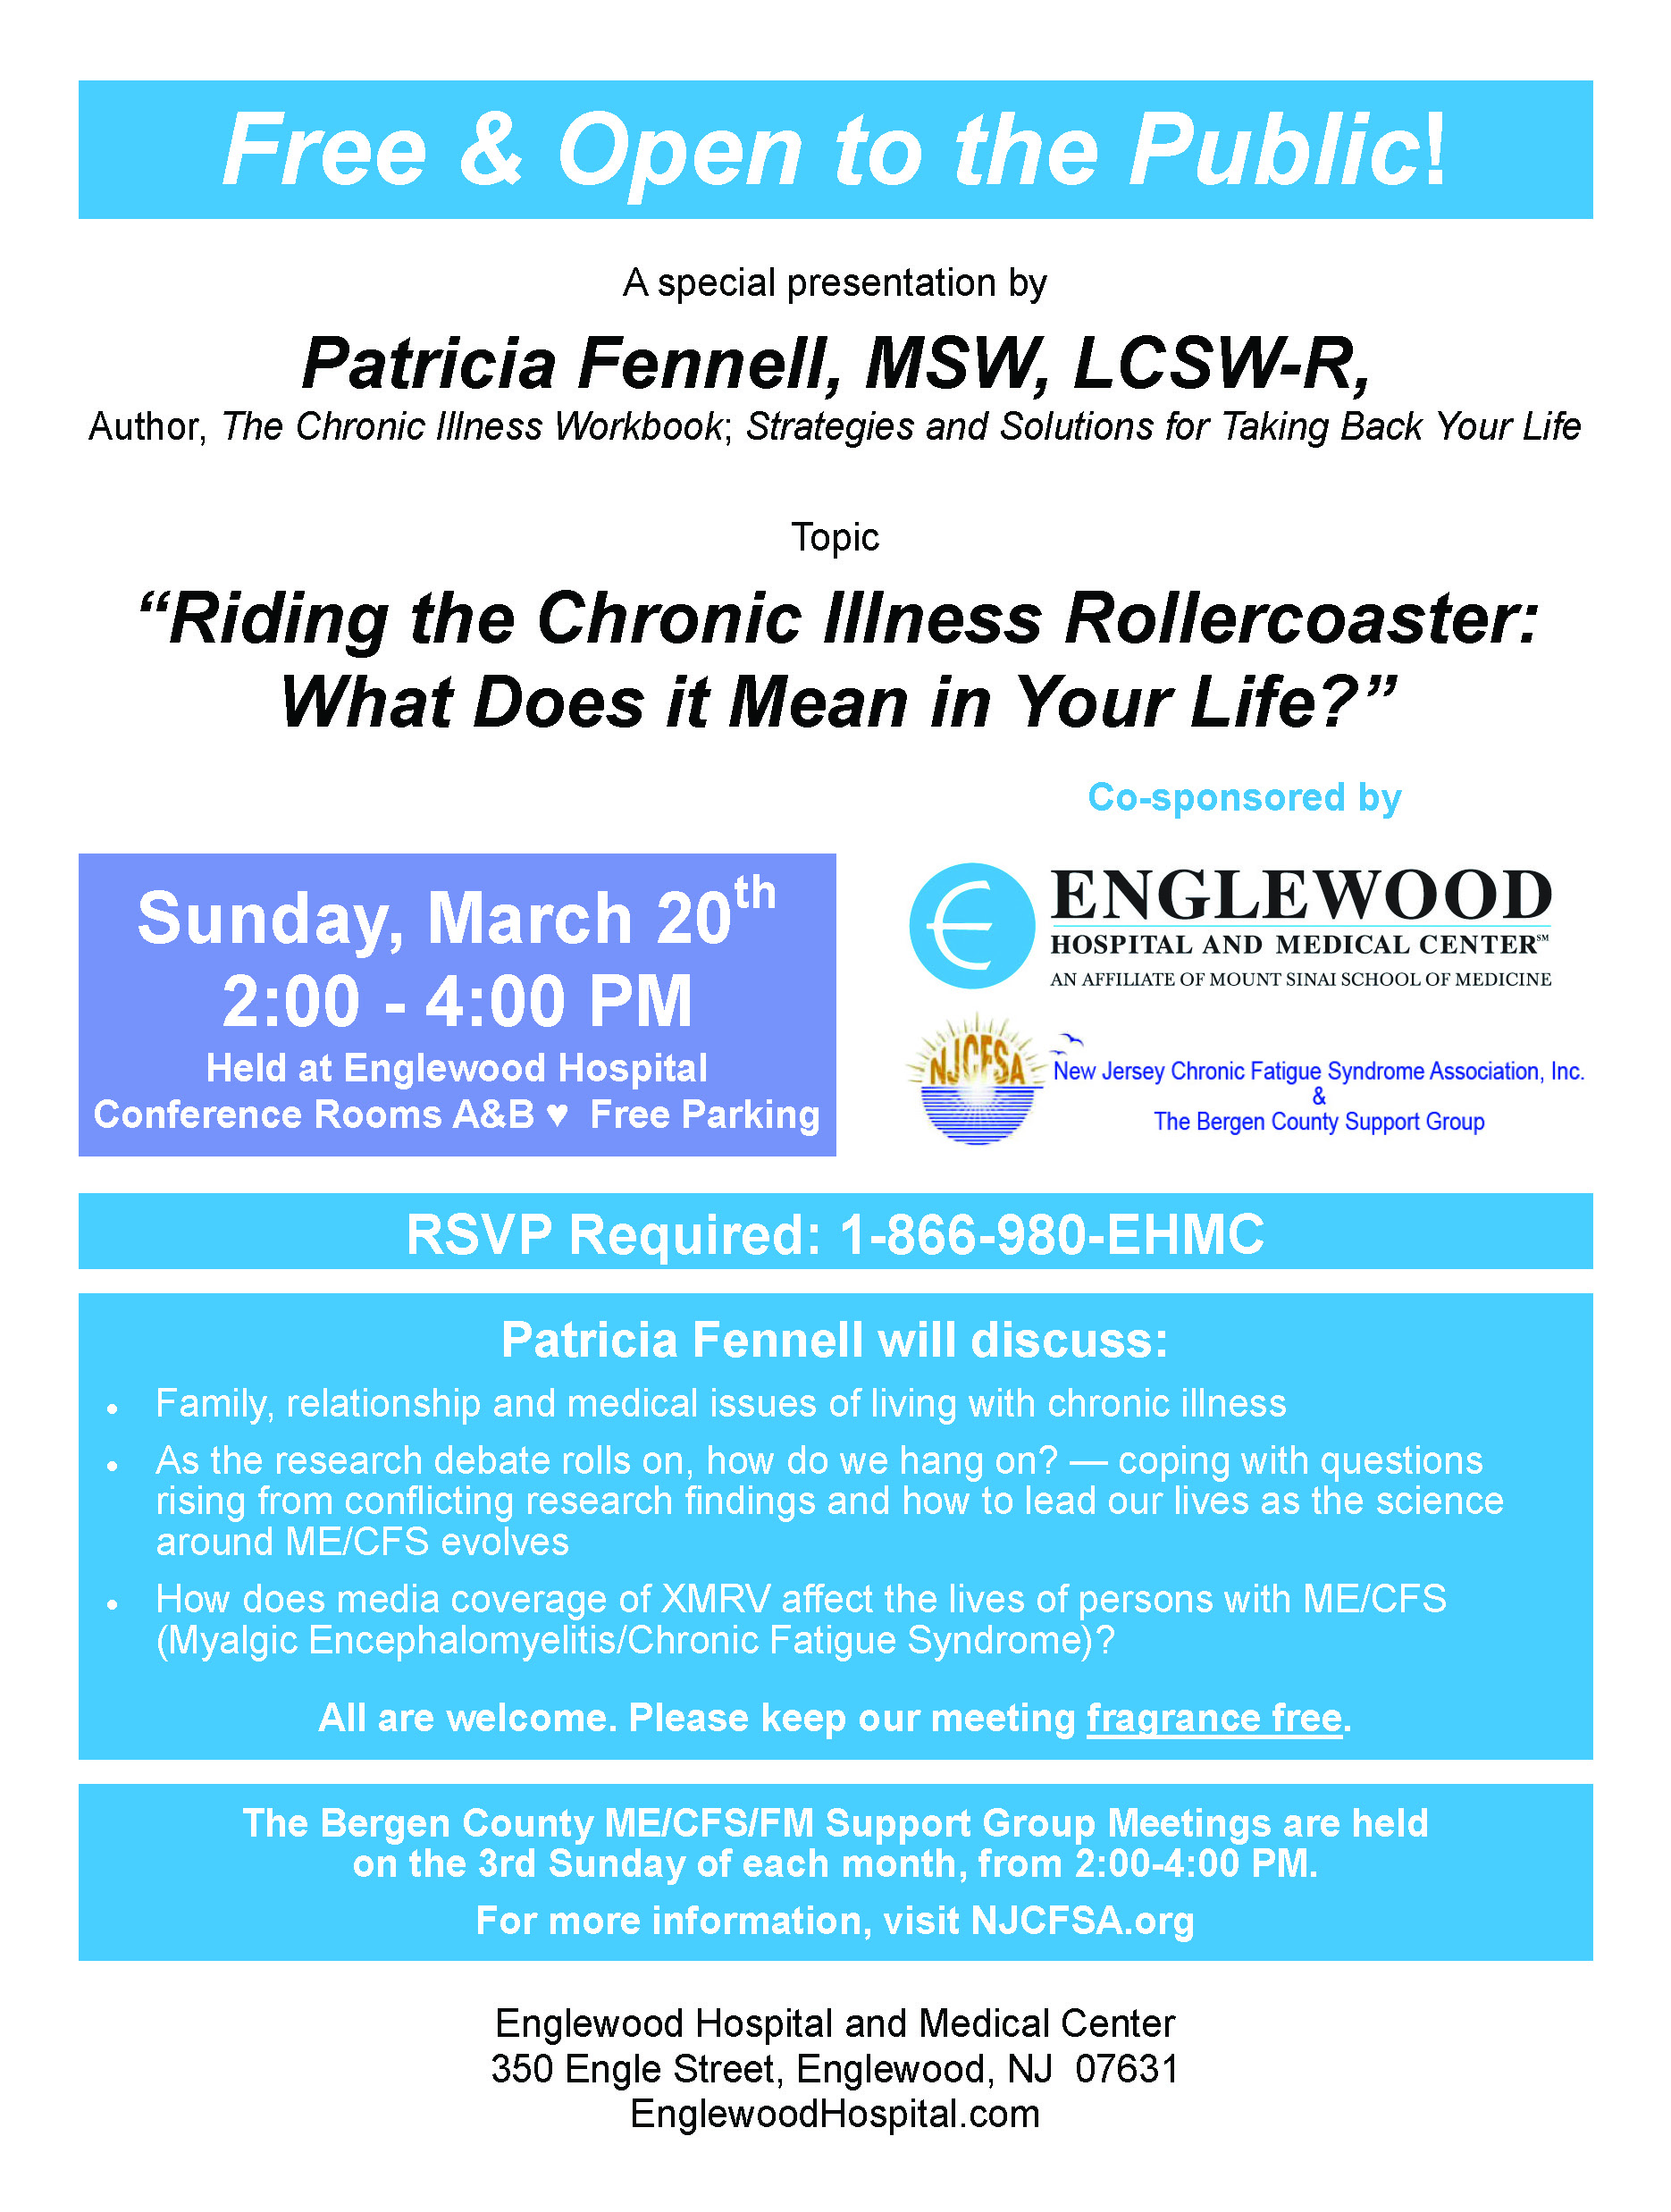
New Information
At the end of this newsletter are updated data sheets: NJCFSA Fact Sheet and NJCFSA XMRV statement. For formatted printable versions, please go to www.njcfsa.org
Next Meeting
The next meeting will be held on March 20th. Please see the announcement for that meeting in this newsletter.

This newsletter is intended for ME/CFS & FM patients in the area of this support group. The purpose is to share information and support. If you have questions about meetings please contact: Nancy Visocki at ngv.njcfsa@verizon.net, Judy Machacek at judymachacek@msn.com, Pat LaRosa at pcl.njcfsa@gmail.net or leave a voice message at the JCFSA HelpLine 888-835-3677 during business hours. Please note: The HelpLine is not in a staffed office. It is voice mail that is answered by NJCFSA volunteers – within 48 hours (sometimes sooner.) If you are in crisis, seek emergency assistance (such as 911.)

WEATHER or EMERGENCY – In the event of bad weather, or other emergency, we encourage you to check your email before leaving for Englewood. If it has been decide that a meeting will be canceled, an email will be sent via the yahoogroups list. The Hospital will also be notified of the cancellation. The email posting also applies to a cancellation of the First Wednesday of the Month luncheon which is an informal gathering, an opportunity for people to meet and chat with other members.

