2008 NJCFSA HIGH SCHOOL SCHOLARSHIP WINNER

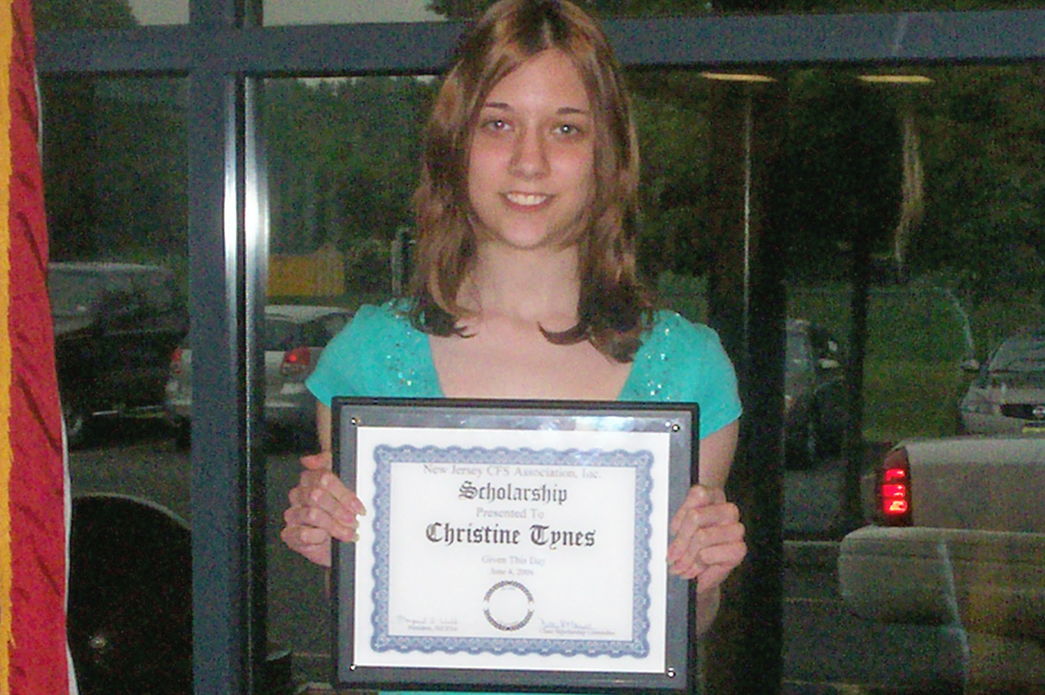

Christine Tynes

“What do you see as your goal for higher education or career direction and has having Chronic Fatigue Syndrome influenced your choice in any way?”

Life has its ups and downs, as well as unexpected twists and turns. Sometimes things take a turn for the worse, but we have to learn to struggle through and get past these obstacles. Having chronic fatigue syndrome has been like a roadblock in the way of accomplishing my goals, but where there is a roadblock, there is always a detour. My way of getting around this illness has been keeping a positive attitude and continuing to try my best. It will become easier to reach the end of the path to success because of the hard work and dedication I put into everything I do.

Last summer was when I started having symptoms. One night, I suddenly felt extremely tired and weak. I had no idea what was going on, and most of the doctors I went to didn’t know either. After many long months of waiting - with no answers, going to several doctors, having three MRI’s, and getting so many blood tests I lost count - I was diagnosed with Chronic Fatigue Syndrome.

At first I thought that it would be something I would have to deal with for the rest of my life, and I’d be too exhausted to do anything. However, almost a year later, I am still an honor student at school, in the top eight percent of the senior class. This year, I have become the online editor of my school newspaper, which requires a lot of work to keep it current and up to date. Although I have symptoms that get in the way of doing my schoolwork, I try to not let them affect me.

My health has not affected my career decision because nothing will stop me from doing what I love. When I was younger, my goal was to be a teacher or a writer, and I practiced by teaching my sister, and writing and illustrating stories. My career goals have changed since then, but I am still just as ambitious as I used to be. I have always loved art because it gave me the opportunity to express myself and be creative. In high school, I discovered that I love graphic arts, and I plan on studying graphic design in college this fall.

Although I don’t think chronic fatigue syndrome has changed my career direction, I do believe that it has made an impact on the way I perceive things. I am stronger than I was before, and whenever I am faced with a difficult situation, I have the willpower and determination to fight through it. I am a better person today because of all I’ve been through and experienced in the past year, and I am going to continue to maintain my optimistic attitude in the future.

Christine Tyne 2008

